Name : Jawad Ahmed

Roll No : 20P-0165

Section : BCS-5A

Lab No 5

**Task:** How to configure an email server in Packet Tracer

**Step1:** Create This Topology.

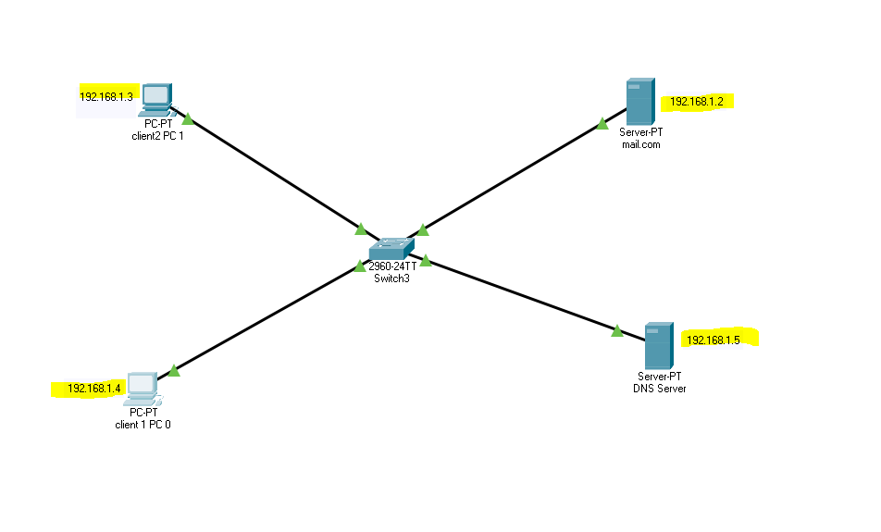

**Step2:** Configure IP addresses on the PCs, DNS Server and the Mail Server

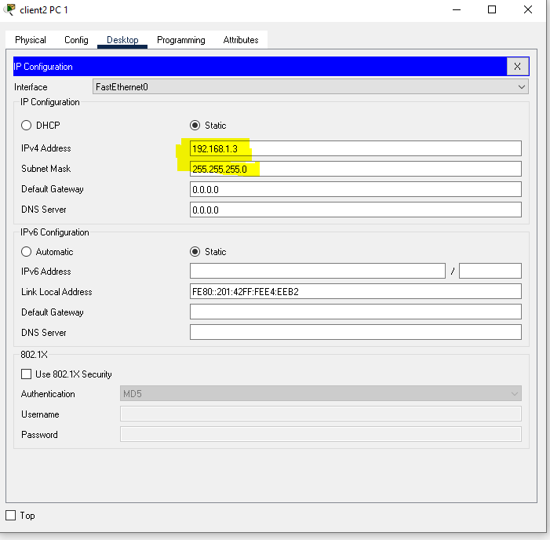

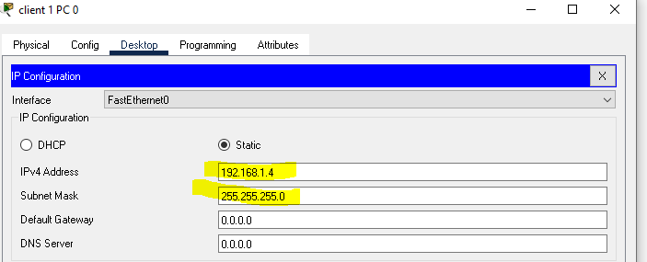

Assigning IP to mail server.

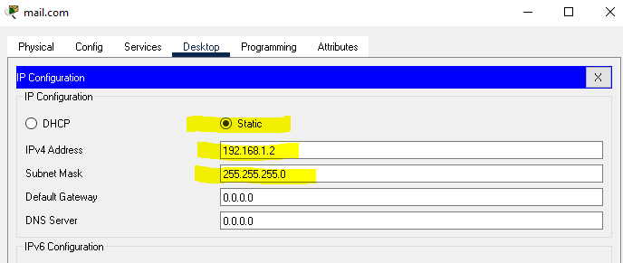

Assigning IP to DNS server.

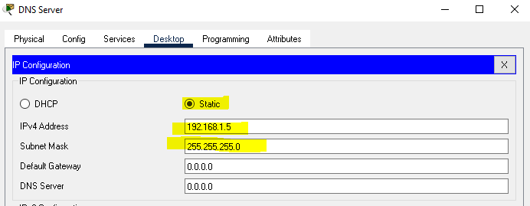

**Step3:** Configure mail clients on the PC’s and mail service on the generic server.

Click on PC0. Go to its Desktop tab, and click on Email. Configure the email client by filling in the user, server and login information. Be sure to Save

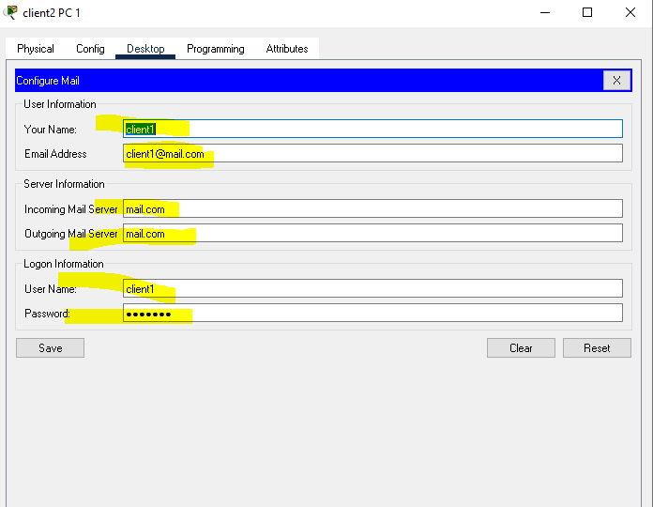

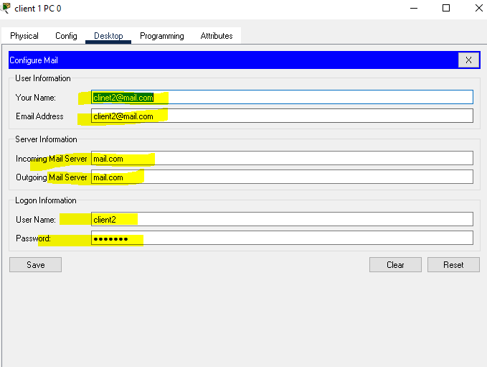

**Mail Server:**

1. Next, we’ll configure the email server. To do this, click on the server, then click Services tab, pick email server from the menu.
2. Provide the Domain name of the server then click on Set to set it. In this example I’ve used the name ‘mail.com’ . Proceed and add users and provide their passwords.
3. I have two email clients(users) with usernames ‘client1‘ and ‘client2’ .
4. After entering a username and password, click on Add(+) to add the user to the server. You can optionally remove a user by clicking on Remove (-). You can change a user’s password by clicking on change password

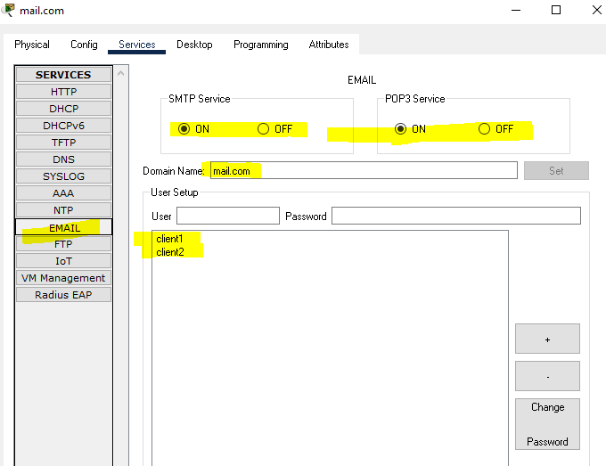

Now configure DNS server.

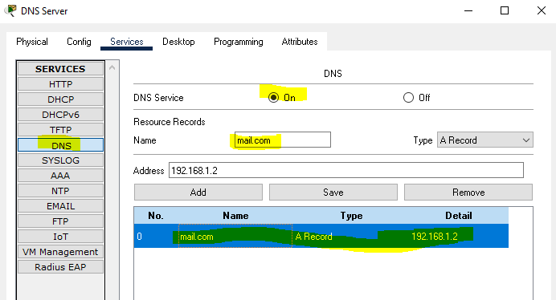

**Now send email from PC0 to PC1 and reply from PC1 to PC0.**



